Design Doc Template

*Author(s): M vyshnavi*

*Date: 25/05/2019*

Revision: 0

Document Status: Draft [Draft, Completed, Submitted, Reviewed, Final]

Project Status: In-Progress [In Review, Approved, In-Progress, Completed]

Revision History

|  |  |  |  |
| --- | --- | --- | --- |
| Date | Revision | Description | Author |
| 25/05/2019 | 0 | Initial draft of the design doc template | M vyshnavi |
|  |  |  |  |
|  |  |  |  |
|  |  |  |  |
|  |  |  |  |
|  |  |  |  |
|  |  |  |  |
|  |  |  |  |
|  |  |  |  |
|  |  |  |  |

Table of Contents

TOC \o "1-3" \h \z \u Introduction4

Summary4

Background4

Definitions, Acronyms, and Abbreviations4

Design Overview4

Requirements4

Documentation4

Minimum Viable Product5

Stretch goals5

Future work5

Architectural Diagrams5

System Diagrams5

Application Programming Interface5

Recommendations5

User Interface6

Data Models and Storage6

Service Operability6

Key Performance Indicators6

Service Level Objectives6

Project Overview7

Communication and Tracking7

Risks7

Milestones7

Project Phases7

Cost7

Frequently Asked Question7

References7

Addendum8

# Introduction

## Summary

Farmers have small pieces of lands which makes it difficult for them to afford tractors and harvesters.

Therefore, the solar powered multipurpose agricultural robot will be a cost effective solution.

## Background

Farmers have small pieces of lands which makes it difficult for them to afford tractors and harvesters as

tractors and harvesters are huge machines, run on fossil fuel, which require lot of investment.

Cost to buy fossil fuel is high and also causes pollution. Therefore, solar powered agriculture robot would solve these issues as it is small in size, uses renewable energy and does the work of tractor and harvester.

Farmers are benefitted as this would help them cut down on investment to buy tractors and harvesters. They can get higher return on investment. Also, we can cut down on environmental pollution.

## Definitions, Acronyms, and Abbreviations

Renewable energy: Energy that is replenishable.

Fossil fuel: petrol, diesel (extinguishable sources)

ROI: Return on Investment

# Design Overview

## Requirements

Farmer requires a robot which performs multiple tasks which is available at low cost.

## Minimum Viable Product

The multipurpose agricultural project can plough, sow seeds, level land, water the crop and harvest the crop. This uses solar power which is renewable energy.

# Architectural Diagrams

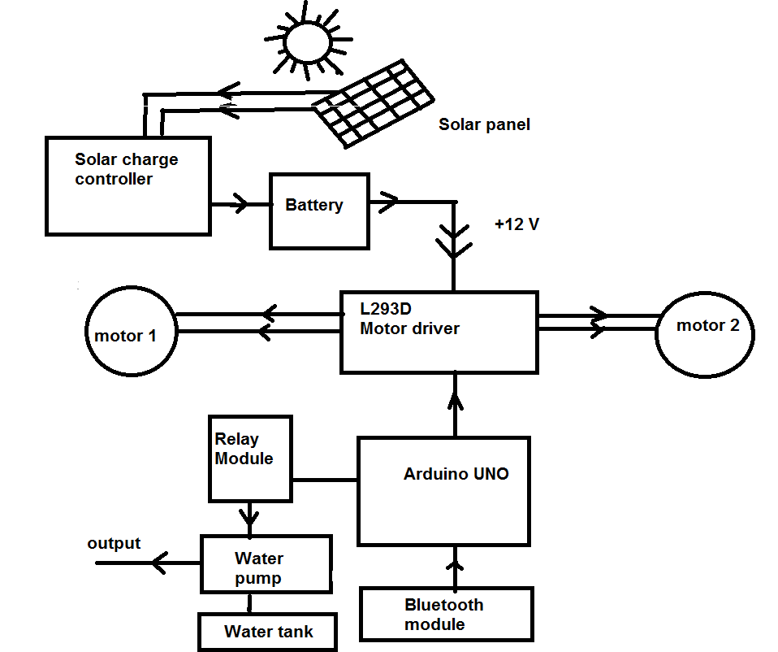

# User Interface

Arduino UNO

# Service Operability

## Key Performance Indicators

KPI can be determined by measuring the area covered by the robot in a given time.

Also, by measuring the number of man hours reduced.

## Service Level Objectives

The amount of battery remaining in the robot and the number of man hours left.

# Project Overview

## Risks

Availability of sun during rainy and winter seasons.